Cadet Name: _____________________________________________
LET:__________
Company:_____________
Date: ________________

1. (U1C1L4:G1) Name the three types of unit decorations.

A) Physical fitness awards, participation awards, and time-in-grade awards
B) Squad, team, and platoon unit decorations
C) Merit Unit, Honor Unit, and Honor Unit with Distinction
D) None of the above

2. (U1C1L4:G2) What are two kinds of awards given to Cadets?

A) Team and squad awards
B) Personal awards and public awards
C) Unit awards and individual awards
D) Physical Fitness Awards and Academic Achievement Awards

3. (U1C1L4:G3) Where is the Merit Unit insignia worn on a class A or B uniform?

A) Above the right shirt pocket.
B) Centered over the left shirt button pocket.
C) On the shoulder board above the rank designators.
D) None of the above

4. (U1C1L4:G4) What color is the Honor Unit with Distinction insignia and where is it worn?

A) The yellow five-pointed star is worn above the right pocket of the class A or B uniform.
B) The blue six-pointed star is worn above the right pocket.
C) The red triangle is worn above the left pocket of class A or B uniforms.
D) The yellow five-pointed star is worn on the shoulder boards of a uniform.

5. (U1C1L4:G5) What are the two main categories of individual awards given to Cadets for superior performance?

A) Institutional and national awards
B) Personal recognition and public recognition awards
C) Merit unit awards and scholastic excellence awards
D) Team and squad awards

6. (U1C1L4:G9) T or F: The Recruiting Ribbon is awarded to those Cadets who are recruited into the military while in high school.

A) True
B) False

7. (U1C1L4:G10) To win the Physical Fitness Award, male Cadets must be able to run a mile in how many minutes?

A) 10:00 or less
B) 9:30 or less
C) 8:30 or less
D) 6:30 or less

8. (U1C1L4:G11) To win the Physical Fitness Award, female Cadets must be able to run a mile in how many minutes?

A) 6:45 or less
B) 10:45 or less
C) 7:30 or less
D) 8:30 or less

9. (U1C1L4:G13) The Merit Unit, Honor Unit, and Honor Unit with Distinction are three types of __________ awards.

A) Unit
B) Battalion
C) Academic
D) Performance

10. (U1C1L4:G17) To whom is the Superior Cadet Award awarded?

A) It is awarded annually to the Cadet with the highest G.P.A. in each LET level.
B) It is awarded annually to the most physically fit Cadet in each LET level.
C) It is awarded annually to the most decorated Cadet in each LET level.
D) It is awarded to Cadet staff officers for outstanding performance.

11. (U1C1L4:G20) Which awards come first in the order of merit -military awards, athletic awards, or academic awards?

A) Military awards
B) Athletic awards
C) Academic awards
D) All have equal merit
12. (U1C1L4:G21) T or F: Military awards come in the first order of merit of the awards given in JROTC.
A) True
B) False

13. (U1C1L4:G24) Name the three types of unit decorations in JROTC.
A) Personal Unit, Merit Unit, and School Unit with Distinction
B) School Unit, Personal Unit with Distinction, and Team Unit
C) Team Unit, School Unit, and Merit Unit with Distinction
D) Merit Unit, Honor Unit, and Honor Unit with Distinction

14. (U1C1L4:V2) Choose the word that best describes the scenario below.
Lauren was excited to go to a ceremony where she would be acknowledged for her softball skills.
A) unit award
B) academic award
C) miscellaneous award
D) athletic award

15. (U1C1L4:V3) Choose the word that best describes the scenario below.
Justin was recently acknowledged by the principal of the school for his outstanding community service.
A) military award
B) individual award
C) athletic award
D) academic award

16. (U1C1L4:V4) Choose the word that best describes the scenario below.
Roger has several ribbons and medals on his uniform, indicating his many accomplishments in JROTC.
A) commitment
B) motivation
C) decorations
D) responsibility

17. (U1C1L4:V5) Choose the word that best describes the scenario below.
Mary's teachers unanimously decided she should be recognized for all of her hard work in biology. What kind of award would they give Mary?

A) academic award
B) individual award
C) unit award
D) athletic award

18. (U1C1L4:V6) Choose the word that best describes the scenario below.
Jerry was very excited about today. His unit was to be recognized for their hard work. What kind of award was Jerry's unit receiving?
A) miscellaneous award
B) unit award
C) motivation
D) responsibility

19. (U1C1L4:V7) Choose the word that best describes the scenario below.
Sandy spilt some soda on the floor at lunch when no one was looking. Instead of leaving the mess, she cleaned it up. By doing this, what was Sandy taking for her actions?
A) unit award
B) individual award
C) responsibility
D) athletic award

20. (U1C1L4:V8) Choose the word that best describes the scenario below.
Robin is to receive the Personal Appearance Ribbon today. What type of award is this?
A) commitment
B) motivation
C) decorations
D) military award

21. (U1C1L3:Q1) From highest to lowest, what is the correct order of Cadet officer ranks?

A)
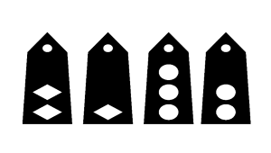
B)
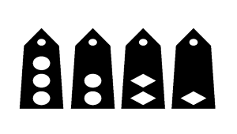
C)
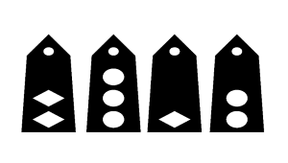
D)
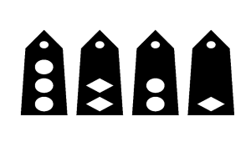

22. (U1C1L3:Q2) If you met a Cadet with this rank, how should you greet her?

A) "Good morning, Cadet Staff Sergeant."
B) "Good morning, Cadet Sergeant."
C) "Good morning, Cadet Master Sergeant."
D) "Good morning, Ma'am."

23. (U1C1L3:Q3) As a new Cadet, you are being introduced to your chain of command. The person wearing this rank is most likely your ___________________.

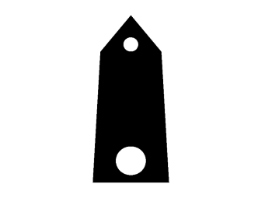
A) Battalion Commander
B) Company Commander
C) Platoon Leader
D) Squad Leader

24. (U1C1L3:Q4) Your job is to make sure the Battalion Commander's guidance is understood and acted on by the Company Commanders and the Battalion Staff. You also manage the staff so that all of the different staff sections coordinate and work with each other to advise the Commander, plan projects and activities, perform administrative duties, maintain security, and issue property.
What is your position in the Battalion?
A) Adjutant (S-1)
B) Battalion Coordinating Staff Officer
C) Battalion Command Sergeant Major
D) Executive Officer (XO)

25. (U1C1L3:G1) T or F: In the pyramid of authority in JROTC, from the top to the bottom of the pyramid is a chain of command.
A) True
B) False

26. (U1C1L3:G2) Define "chain of command."
A) Number of immediate subordinates under one's control.
B) The succession of leaders through which authority passes down the ranks.
C) The pyramid of authority.
D) The rank or grade held by a Cadet JROTC member.

27. (U1C1L3:G3) What is the purpose of using the chain of command?
A) To prevent lawsuits against enlisted personnel.
B) To limit the number of individuals in one's span of control.
C) To ensure the unity of a command.
D) It ensures that all members are working together as a team to accomplish their individual tasks and those of the unit.

28. (U1C1L3:G4) Define "span of control."
A) The number of immediate subordinates, one commander, or leader can effectively control, supervise, or direct.
B) Synonymous with chain of command.
C) The duties of the S-2, who is responsible for staff matters pertaining to security.
D) The number of supervisors one answers to in any given day.

29. (U1C1L3:G74) Name the three levels of authority in the pyramid of authority.
A) Unity of command, Span of control, Chain of command
B) Enlisted, Warrant, and Officer ranks
C) Basic, Intermediate, and Top
D) Subordinates, Self, and Supervisors

30. (U1C1L3:G5) The two terms used by the military to classify soldiers are ___________ and __________.
A) Rank and grade
B) Officer and enlisted
C) Male and female
D) Retired and active duty

31. (U1C1L3:G6) Explain the difference between the military terms "ranks" and "grade."
A) Rank is a title indicating a Soldier's position and responsibility, while grade is a letter/number combination denoting a Soldier's pay rate.
B) Rank applies only to enlisted Soldiers, while grade applies to officers.
C) Rank is from O-2 to O-6, while grade is from PFC to E-8.
D) Rank has to do with a drill movement, while grade refers to LET-level.

32. (U1C1L3:G13) A company consists of a headquarters section and at least two ______________.
A) Battalions
B) Teams
C) Squads
D) Platoons

33. (U1C1L3:G17) To whom does the Cadet Battalion Commander report?
A) The First Sergeant of the command.
B) Up and down his or her chain of command.
C) To the Army Instructors and to the principal.
D) No one. Others report to the Cadet Battalion Commander.

34. (U1C1L3:G19) What is the rank of a JROTC Battalion Commander?
A) Cadet Lieutenant
B) Cadet Lieutenant Colonel
C) Cadet Captain
D) Cadet Major

35. (U1C1L3:G20) What is the rank of a JROTC Company Commander?
A) Cadet Major
B) Cadet Captain
C) Cadet Lieutenant Colonel
D) Cadet First Sergeant

36. (U1C1L3:G21) What is the rank of a JROTC Battalion Executive Officer?
A) Cadet Captain
B) Cadet Colonel
C) Cadet Major
D) Cadet General
37. (U1C1L3:G22) Who in a unit is primarily responsible for staff matters pertaining to security?
A) The S-3, also called the Training Officer.
B) The JROTC Senior Army Instructor.
C) The S-2, also called the Battalion Intelligence or Security Officer.
D) The Information Officer

38. (U1C1L3:G23) What are the primary responsibilities of the Battalion S-3?
A) To answer media questions.
B) To assist the Battalion Commander in the preparation, conduct, and supervision of all Cadet battalion training activities.
C) To track JROTC inventory of property.
D) To advise the staff on the conditions of all weapons.

39. (U1C1L3:G24) Whose job is it to act as the contact between the corps of cadets and all news media and student publications?
A) The Battalion Ordinance Officer
B) The Battalion Public Affairs Officer, also called the Information Officer
C) The Battalion Supply Officer
D) The Battalion Logistics Officer

40. (U1C1L3:G26) Who is responsible for setting up and maintaining all signal or public address/projection/sound equipment issued to the Cadet battalion?
A) The Battalion Information Officer
B) The Battalion Communications Officer, also called the Signal Officer
C) The Battalion Logistics Officer
D) The Battalion Supply Officer

41. (U1C1L3:G27) Who is responsible for the maintenance, security, record keeping, issue, and turn-in of all U.S. government property (except ordnance) for the battalion?
A) The Battalion Signal Officer
B) The Battalion Information Officer
C) The Battalion Logistics or Supply Officer, also known as the S-4
D) The Battalion Commander

42. (U1C1L3:G28) What are the responsibilities of a team leader?
A) A team leader is responsible for publicizing all the accomplishments of the team.
B) A team leader is responsible for monitoring team spirit and team attendance at school events.
C) A team leader is responsible for the formation, appearance, training, and discipline of their team members and must be ready to assume control of the squad in the absence of the squad leader.
D) All of the above

43. (U1C1L3:G29) Name the duties and responsibilities of a team member.
A) Properly wear the uniform.
B) Take care of equipment.
C) Be on time for official formations.
D) All of the above

44. (U1C1L3:G31) The number of immediate subordinates, one commander, or leader can effectively control, supervise, or direct describes the leader's ______________.
A) Unity of command
B) Span of control
C) Chain of command
D) Pyramid of authority

45. (U1C1L3:G35) The person responsible for the preparation, conduct, and supervision of all Cadet battalion training activities is the _____________.
A) S-5, also called the Special Projects Officer.
B) S-4, also called the Logistics Officer
C) S-3, also called the Battalion Operations and Training officer
D) S-1, also called the Adjutant

46. (U1C1L3:G44) Who is the company commander's primary assistant?
A) The Senior Army Instructor
B) The company executive officer (or XO)
C) The Squad leader
D) The battalion command sergeant major

47. (U1C1L3:G45) Who assumes command in the absence of the company commander?
A) The battalion command sergeant major
B) The platoon leader
C) The Special Projects Officer (or S-5)
D) The company executive officer (or XO)

48. (U1C1L3:G52) Who is responsible for all the battalion does or fails to do?
A) The Executive Officer
B) The Senior Army Instructor
C) The Command Sergeant Major
D) The Battalion Commander

49. (U1C1L3:G49) Who is the administrative assistant to the battalion commander?
A) The battalion Operations or Training Officer (or S-3)
B) The battalion Special Projects Officer (or S-5)
C) The battalion Ordinance Officer
D) The battalion adjutant (or S-1), who is usually a Cadet captain or major

50. (U1C1L2:V1) Choose the word that best completes the sentence below.
As a leader, Bob was able to settle disputes in a cohesive manner using his _____________ skills.
A) leadership
B) conflict resolution
C) National Defense Act
D) culturally diverse

51. (U1C1L2:V2) Choose the word that best completes the sentence below.
JROTC prepares high school students for responsible ________ roles while making them aware of the benefits of citizenship.
A) leadership
B) conflict resolution
C) National Defense Act
D) culturally diverse

52. (U1C1L2:V3) Choose the word that best completes the sentence below.
The local high school has many students who are from all over the world, making the school ________.
A) leadership
B) conflict resolution
C) National Defense Act
D) culturally diverse

53. (U1C1L2:V4) Choose the word that best completes the sentence below.
The US Army Junior Reserve Officers' Training Corps (JROTC) formally came into being with the passage of the ___________ in 1916.
A) leadership
B) conflict resolution
C) National Defense Act
D) culturally diverse

54. (U1C1L2:Q2) Teamwork is the ability to work well with others towards a common goal. It is one of the hallmarks of Army JROTC. If you were describing some of the activities you do in JROTC to develop teamwork, what would you most likely be talking about?
A) Classes that teach the dangers of substance abuse
B) Drill and ceremonies, first aid, and map reading
C) Goal-setting and financial planning
D) The importance of diet and exercise in maintaining good health

55. (U1C1L2:G1) When was JROTC established by Congress?
A) 1961
B) 1916
C) 1776
D) 1830

56. (U1C1L2:G2) Name the congressional act that launched the JROTC program.
A) The Civil Rights Act
B) The No Child Left Behind Act
C) The National Fitness Act
D) The National Defense Act of 1916

57. (U1C1L2:G3) Where in the U.S. was the first JROTC program established as the American Literary, Scientific, and Military Academy?
A) Connecticut
B) Virginia
C) Sacramento, California
D) Norwich, Vermont

58. (U1C1L2:G4) One of the goals of the JROTC curriculum is to encourage students to graduate from _____________.
A) College
B) High School
C) Basic Training
D) Two-Year Colleges

59. (U1C1L2:G5) T or F: One of the LET goals for Cadets is to get Cadets to graduate from high school.
A) True
B) False

60. (U1C1L2:G6) T or F: One of the LET goals is to get Cadets to join the military service.
A) True
B) False

61. (U1C1L2:G7) T or F: One of the LET goals is to teach Cadets conflict resolution skills.
A) True
B) False

62. (U1C1L2:G8) JROTC was established in the year ___________ by an act of Congress.
A) 1942
B) 1902
C) 1916
D) 1776

63. (U1C1L2:G9) The academy in Norwich, Vermont, which had the first JROTC program was the ___________ Academy.
A) American Literary, Scientific, and Military
B) Military
C) West Point
D) American Military

64. (U1C1L2:G10) T or F: The mission of JROTC is to train citizen soldiers for the future of the U.S.
A) True
B) False

65. (U2C2L4:V1) Parade Rest
A)

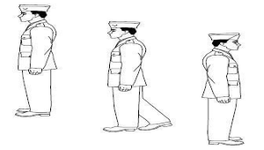
B)

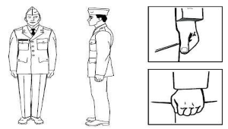

C)
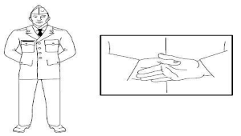
D)
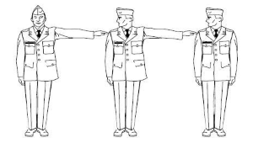

66. (U2C2L4:V2) Attention
A)

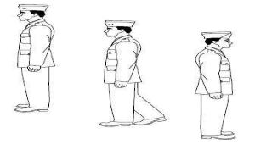
B)
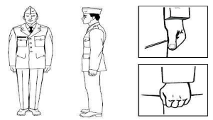

C)
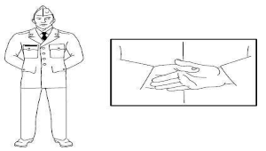
D)
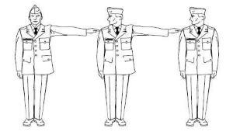

67. (U2C2L4:V3) Choose the word that best matches the definition below.
"Command to relax the body while remaining silent in place and not assuming any particular position."
A) Attention
B) At Ease
C) Parade Rest
D) Rest

68. (U2C2L4:V4) Facing: Pivoting movement executed while stationery to orient the body left, right, or opposite current position.
What type of face is shown in the picture?

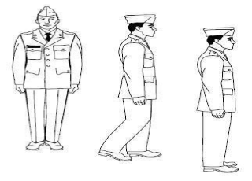
A) Opposite Face
B) Left Face
C) About Face
D) Right Face

69. (U2C2L4:V5) Choose the word that best matches the definition below.
"A position where you remain standing with your right foot in place;
in certain situations, you may move or talk in this position unless otherwise directed."
A) Salute
B) Rest
C) At Ease
D) Attention

70. (U2C2L4:V6) Is this salute being properly executed?

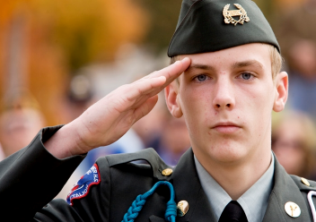

A) Yes
B) No

71. (U2C2L4:V4) Facing: Pivoting movement executed while stationery to orient the body left, right, or opposite current position.
What type of face is shown in the picture?

A) Opposite Face
B) Left Face
C) About Face
D) Right Face

72. (U2C2L5:V1) Choose the word that best matches the definition below.
"A prescribed distance from one heel to the
other heel of a marching soldier."

A) double time
B) halt
C) quick time
D) rest
E) steps

73. (U2C2L5:V2) Choose the word that best matches the definition below.
"A command to bring a moving formation to a standstill."
A) double time
B) halt
C) quick time
D) rest
E) steps

74. (U2C2L5:V3) Choose the word that best matches the definition below.
"A relaxed form of march without a set cadence to conserve troops' energy."
A) double time
B) halt
C) quick time
D) rest
E) steps

75. (U2C2L5:V4) Choose the word that best matches the definition below.
"Standard marching pace of 120 steps per minute."

A) double time
B) halt
C) quick time
D) rest
E) steps

76. (U2C2L5:V5) Choose the word that best matches the definition below.
"Fast marching pace of 180 steps per minute."

A) double time
B) halt
C) quick time
D) rest
E) steps

77. (U2C2L6:V1) What is the definition of the word "line"?
A) to form up in column
B) to form up in files, facing forward the width of the formation
C) to form up line abreast
D) to form up in ranks, facing forward the length of formation

78. (U2C2L6:V2) What is the definition of the word "flank"?
A) the side of the formation, either left or right
B) to form up in ranks, facing forward the length of formation
C) to form up line abreast
D) patterned arrangement of troops

79. (U2C2L6:V3) What is the definition of the word "column"?
A) to form up line abreast
B) to form up in ranks, facing forward the length of formation
C) the side of the formation, either left or right
D) to form up in files, facing forward the width of the formation

80. (U2C2L6:V4) What is the definition of the word "rank"?
A) the side of the formation, either left or right
B) to form up line abreast
C) two arms' distance between troops in rank formation
D) to form up in column

81. (U2C2L6:V5) What is the definition of the term "double interval"?
A) two arms' distance between troops in rank formation
B) elbow's distance between troops in rank formation
C) to form up in ranks, facing forward the length of formation
D) single arm's distance between troops in rank

82. (U2C2L6:V6) What is the definition of the word "file"?
A) to march in position
B) to turn in position
C) the side of the formation, either left or right
D) to form up in column

83. (U2C2L6:V7) What is the definition of the term "close interval"?
A) two arms' distance between troops in rank formation
B) single arm's distance between troops in rank
C) elbow's distance between troops in rank formation
D) to turn in position

84. (U2C2L6:V8) What is the definition of the word "formation"?
A) patterned arrangement of troops
B) a command for marching in place
C) to form up line abreast
D) to turn in position

85. (U2C2L6:V9) What is the definition of the term "normal interval"?
A) patterned arrangement of troops
B) single arm's distance between troops in rank
C) elbow's distance between troops in rank formation
D) two arms' distance between troops in rank formation

86. (U2C2L6:V10) What is the definition of the word "pivot"?
A) patterned arrangement of troops
B) to form up line abreast
C) to turn in position
D) a command for marching in place

87. (U3C1L1:G1) What is introspection?
A) Giving feedback to others to help them learn.
B) Communicating your learning preferences to others.
C) Self-examination for the purpose of a deeper self-understanding.
D) Examining the actions of others to gain self insight.

88. (U3C1L1:G2) Which of the following are steps in the self-discovery process?
A) Introspection, observation
B) Giving and receiving feedback
C) Using assessment tools
D) All of the above
89. (U3C1L1:G3) Define "assessment."
A) The act of evaluating or appraising a person's ability or potential to meet certain standards or criteria.
B) Judging your peers' weaknesses.
C) Giving a test.
D) Watching a drill movement.
90. (U3C1L1:G4) The assessment tool, Winning Colors®, groups human behavior into categories. Name the four behavior clusters.
A) carpenter, scheduler, activity director, and listener
B) communicator, leader, anticipator, and inventor
C) tester, risker, challenger, and performer
D) builder, planner, adventurer, and relater

91. (U3C1L1:G5) T or F: It is important to be balanced in the four behavior clusters of Winning Colors®.
A) True
B) False

92. ((U3C1L1:G7) __________ means contemplating one's own thoughts or feelings for the purpose of deeper self-understanding.
A) Introspection
B) Observation
C) Assessment
D) Self-assessment

93. (U3C1L1:G8) What is assessment?
A) An infected wound.
B) The act of evaluating or appraising a person's ability or potential to meet certain standards or criteria.
C) An infected tooth.
D) A type of rappelling harness.

94. (U3C1L1:F2) What are the four determinants that impact self-esteem and success?
A) needs, resources, popularity, and maturity
B) builder, planner, adventurer, and relater
C) connections, resources, power, and models
D) goal setting, respect, popularity, and models

95. (U3C1L1:V1) Choose the word that best matches the definition below.
"To group things together when they have common characteristics."
A) cluster
B) introspection
C) associate
D) differentiate

96. (U3C1L1:V2) Choose the word that best matches the definition below.
"Examination of one's own thoughts or feelings."
A) introspection
B) assessment
C) associate
D) cluster

97. (U3C1L1:V3) Choose the word that best matches the definition below.
"To make a distinction or state a difference between things so we can tell them apart."
A) associate
B) cluster
C) assessment
D) differentiate

98. (U3C1L1:V4) Choose the word that best matches the definition below.
"A number of similar things growing together, or of things or individuals collected."
A) differentiate
B) cluster
C) associate
D) introspection

99. (U3C1L1:V5) Choose the word that best matches the definition below.
"The act of evaluating or appraising a person's ability or potential to meet certain criteria or standards."
A) cluster
B) introspection
C) associate
D) assessment

100. (U1C1L1:Q1) If someone asked you about what you expect to get out of Army JROTC, which one of the following responses would you use to best inform them about the mission and purpose of JROTC?
A) "We expect to learn military skills as future soldiers, sailors, airmen, and Marines for our armed forces. That's the purpose of JROTC."
B) "We expect to develop our personal growth skills as we participate in a variety of experiences and leadership situations to help us be better citizens. That’s the mission of JROTC."
C) "We expect to participate in an alternative method of normal classroom learning. That's the purpose of JROTC."
D) "We expect to save our future employers training dollars by learning leadership skills in JROTC. That's the mission of JROTC."

101. (U1C1L1:Q2) A friend of yours tells you that citizenship can't be developed in a classroom. She believes that people learn citizenship skills from their families. Which of the following answers would you use to best demonstrate your citizenship skills, and to best explain how Army JROTC develops citizenship?
A) "Army JROTC does teach citizenship skills with classroom discussions and public speaking opportunities."
B) "Families can set the foundation for good citizenship, but Army JROTC helps promote it further through projects outside of the home."
C) "I know what you mean, that's why we have study groups that cover a variety of academic subjects both in and out of the classroom."
D) "Army JROTC teaches us how we could be good citizens by joining the Army or one of the other armed services."

102. (U1C1L1:Q3) Leadership Theory and Application lessons teach Cadets the BE, KNOW, and DO of leadership. A friend of yours said that she understood the BE and DO parts, but wasn't sure about the KNOW. Which of the following would be a good example to illustrate what KNOW means?
A) A Cadet receives an award.
B) A Cadet demonstrates a performance task.
C) A Cadet gets promoted to a leadership position.
D) A Cadet motivates a team to accomplish a mission.

103. (U1C1L1:Q4) The JROTC Instructor asked your friend what he knew about Army JROTC. He replied that he had heard both good and bad things about it. He also said that he thought it would be a good place to learn leadership, but that he was sure he wasn't going to like some of the challenges. The instructor smiled because she liked his answer, then she thanked your friend for his candor. Your friend didn't know what that meant, so the instructor asked you if you knew.
What should you say?
A) Candor means fairness, openness, and frankness.
B) Candor means obligation, devotion, and duty.
C) Candor means poise, certainty, and self-belief.
D) Candor is integrity, moral fiber, and disposition.

104. (U1C1L1:G1) What is the mission of Army JROTC?
A) To train young men and women in Army tactics.
B) To help students graduate from high school.
C) To increase enlistment in the Armed Forces.
D) To motivate young people to be better citizens.

105. (U1C1L1:G2) In your LET texts, what will Leadership Theory and Application teach you?
A) How to influence others while you are leading them.
B) How to be a leader.
C) What you do while you are leading.
D) All of the above

106. (U1C1L1:V1) Choose the word that best matches the definition below.
"A program that teaches high school students the values of good citizenship while giving them an introduction to the US Army."
A) Cadet
B) mission
C) challenges
D) JROTC

107. (U1C1L1:V2) Choose the word that best matches the definition below.
"A specific job given to a person or group of persons to accomplish."
A) Cadet
B) mission
C) unique
D) JROTC

108. (U1C1L1:V3) Choose the word that best matches the definition below.
"A high school student enrolled in the leadership and citizenship activities through JROTC."
A) Cadet
B) mission
C) unique
D) motivate

109. (U1C1L1:V4) Choose the word that best matches the definition below.
"Being the only one of its kind."
A) Cadet
B) opportunities
C) unique
D) JROTC

110. (U1C1L1:V5) Choose the word that best matches the definition below.
"Provide a need or a purpose that causes a person to want to do something."
A) challenges
B) opportunities
C) motivate
D) JROTC

111. (U1C1L1:V6) Choose the word that best matches the definition below.
"To arouse the interest of one's actions or efforts; to stimulate; the quality of requiring full use of one's abilities, energy, and resources; to demand identification from someone before they are allowed to enter or pass."
A) challenges
B) opportunities
C) motivate
D) mission

112. (U1C1L1:V7) Choose the word that best matches the definition below.
"Favorable or advantageous circumstances or a combination of circumstances."
A) challenges
B) opportunities
C) motivate
D) unique

[Answer Key]
1. C
2. C
3. A
4. A
5. A
6. B
7. C
8. B
9. A
10. D
11. C
12. B
13. D
14. D
15. B
16. C
17. A
18. B
19. C
20. D
21. A
22. B
23. C
24. D
25. A
26. B
27. D
28. A
29. A
30. A
31. A
32. D
33. C
34. B
35. B
36. C
37. C
38. B
39. B
40. B
41. C
42. C
43. D
44. B
45. C
46. B
47. D
48. D
49. D
50. B
51. A
52. D
53. C
54. B
55. B
56. D
57. D
58. B
59. A
60. B
61. A
62. C
63. A
64. B
65. C
66. B
67. B
68. B
69. B
70. A
71. B
72. E
73. B
74. D
75. C
76. A
77. D
78. A
79. D
80. B
81. A
82. D
83. C
84. A
85. B
86. C
87. C
88. D
89. A
90. D
91. A
92. A
93. B
94. C
95. C
96. A
97. D
98. B
99. D
100. B
101. B
102. B
103. A
104. D
105. D
106. D
107. B
108. A
109. C
110. C
111. A
112. B

